Design and Creation   
of a Website:

The History of Linux

by

*Justin Muirhead*

## 

## 

# Crest

STUDENT'S NAME: Justin Muirhead

TEACHER'S NAME

DATE SUBMITTED

The following people assisted me in the preparation of this work:

…………………………………………………………………………….

I confirm that the final work I have submitted is all my own work.

I consent to my work being used for moderation purposes.

SIGNATURE OF STUDENT:

**Final Summative Assessment**

|  |  |  |  |
| --- | --- | --- | --- |
| Not achieved | Achieved | Achieved with merit | Achieved with excellence |

Teacher Comment

Student Signature Date

# Time Plan

|  |  |  |
| --- | --- | --- |
| *Date* | *Planned Tasks* | *Actual Tasks Completed, Notes, etc.* |
| 29 Feb |  |  |
| 1 Mar |  |  |
| 2 Mar |  |  |
| 3 Mar |  |  |
| 4 Mar |  |  |
| W/end |  |  |
| 7 Mar |  |  |
| 8 Mar |  |  |
| 9 Mar |  |  |
| 10 Mar |  |  |
| 11 Mar |  |  |
| W/end |  |  |
| 14 Mar |  |  |
| 15 Mar |  |  |
| 16 Mar |  |  |
| 17 Mar |  |  |
| 18 Mar |  | **FINAL DEADLINE!** |

# Communication Purpose of the Website

## Website Topic

The History of Linux

## Intended Audience & Purpose

People interested in The History of Linux. People with only some prior knowledge of computers. The purpose of the page is to inform people of the roots of Linux.

This target audience has changed from a more technical audience to a more general audience as the tone of the information about Linux changed.

# Design of the Website

## Website Pages Planned

|  |  |  |
| --- | --- | --- |
| *Page* | *Page Title* | *Page Purpose and Description* |
| **1** | **Unix** | To describe the precursor to Linux, how that led to Linux and to dip into the BSD’s a bit. |
| **2** | **GNU and Linux** | To talk about the merging of Linux and GNU the naming controversy and X11 |
| **3** | **Shiny, Shiny Distros** | To talk about the variety of distros available today, what they do and their differences. |

## Website Structure

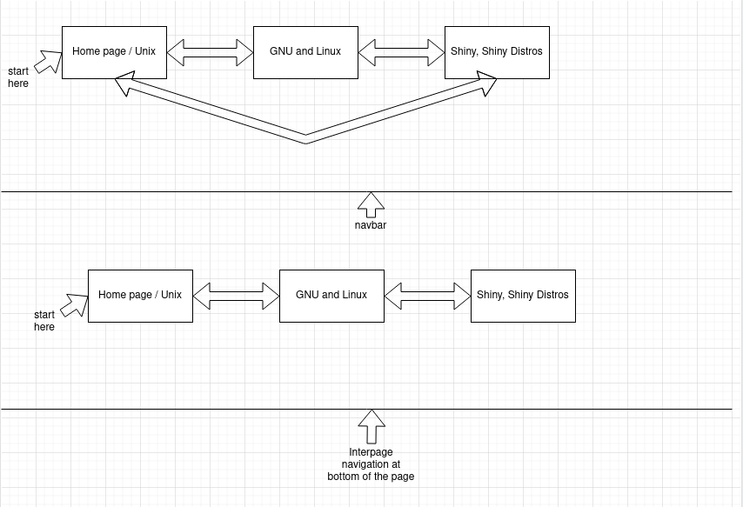

## Website Page Layout(s)

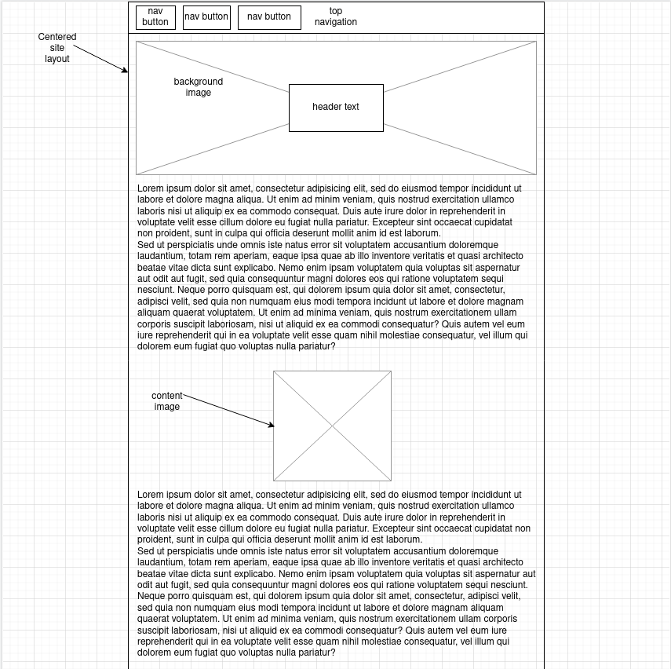

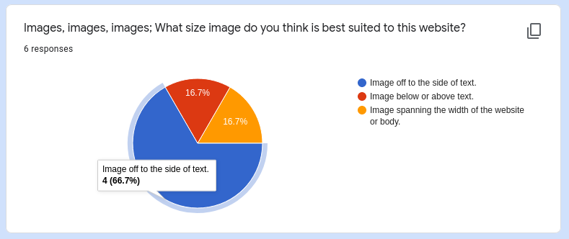based on the results from this poll I decided to change to this design.

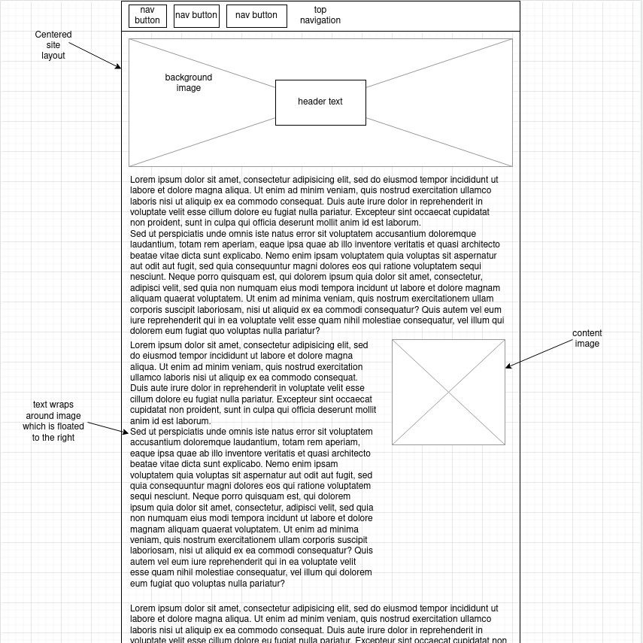This design moves the image to the side of the content.

I decided that the header image wasn’t wide enough so I made it break from the content line.

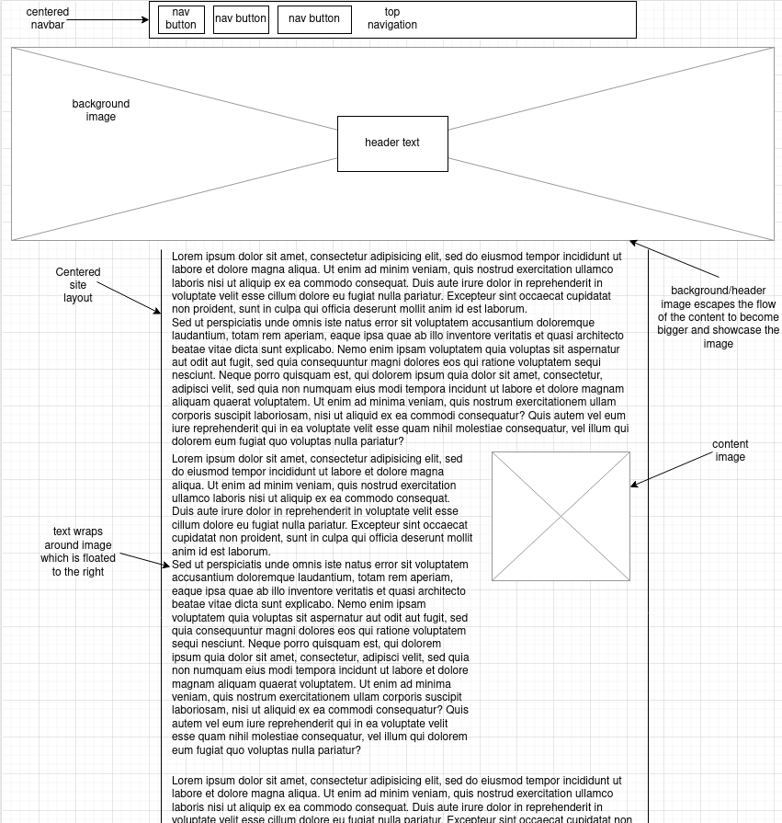Then I added page navigation at the bottom of the page as well as a footer and a progress bar.

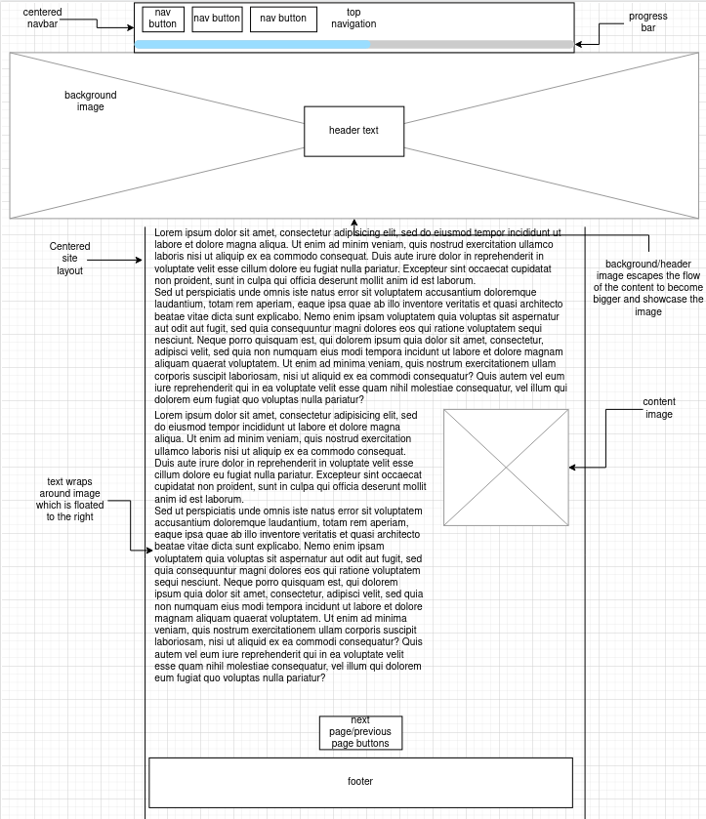After feedback from the tester.

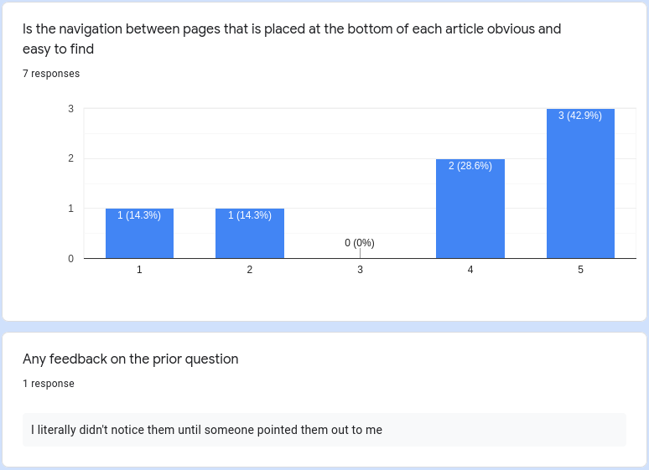I consulted with them and discovered that the bottom navigation wasn’t obvious to most of them.

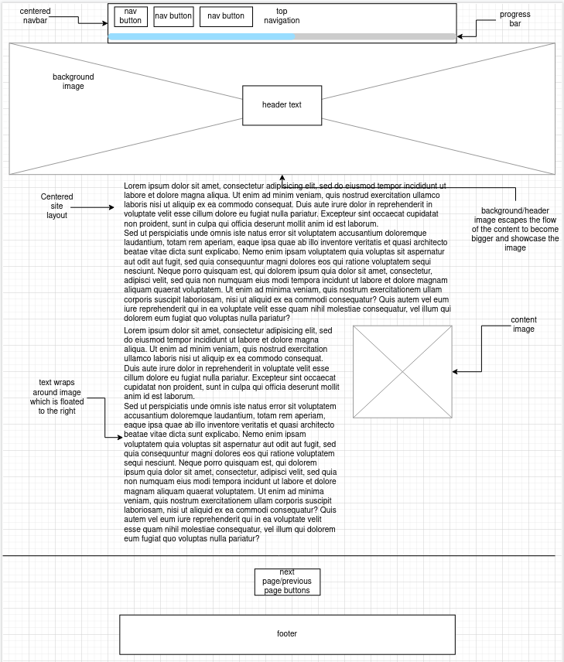When I adapted the in-progress website to this they agreed that the bottom page switching buttons were more obvious.

## Website Design Features

### Color Palette

|  |  |  |  |
| --- | --- | --- | --- |
| *Used For...* | *Color* | *Code / Name* | *Notes* |
| Page background | Dirty white | #F2F2F2 | Makes the white not completely blinding |
| Body Text | Dirty black | #242424 | Makes the black not a complete sinkhole for OLED devices |
| Highlights | Tux yellow | #F6E44A | For that extra tux. Tries to emulate the bright yellow color of Tux’s feet. |

### Font Selection

|  |  |  |  |
| --- | --- | --- | --- |
| *Used For...* | *Font Name* | *Example* | *Notes* |
| Body Text | Ubuntu Weight 300 | Cannot do on this paper | More flairs which makes the font look friendlier. |
| Headings | Questrial | Cannot do on this paper | Less flairs which is good for headings and any large scale font |
| etc... |  |  |  |

### Other Design Features

## Relevant Implications

1.

2.

3.

For each image used the original source as well as any relevant license are linked to. No data is stored so privacy is not an issue. The one image that contains people doesn’t need their permission for reuse as it was published to the public in a book so it is already a public work. All sources for my work is referenced as well as direct quotes, the same applies to images and other files. The ‘tux’ being a trademark in certain jurisdictions and having multiple licenses is referenced at the bottom of each page, as it is used in each page, a disclaimer is also added pertaining to the non-commercial use of tux as well as notifying users of the site that a trademark may apply in their region.

I’ve put my site through a spell checker for readability and to make sure the content is understandable. The content is clean and should be suitable for children and people of all walks of life.

My site uses the descriptive caption text as alt text for the ease of use for both sighted and non-sighted users. The color pallet is black and white for the high contrast and the familiarity with ‘tux yellow’ as a highlight color that doesn’t signify anything, meaning that screen-reader users don’t miss out. All text, apart for spaced and centered headers is left-aligned and spaced by browser defaults, Images and texts are also spaced out and there is no important text in images for screen-reader users.

The site achieves it purpose of informing as many people as possible about the history of Linux. I put the site through a link-checker, sadly the output was to long to include in a screenshot. The site appears as wanted on various mobile, tablet, and desktop devices. The sites users have commented on the ‘clean’ aesthetic of the site.

The images on the site have been resized to their minimum size for their container without reducing the quality of certain diagrams like the family tree diagram of Unix. The HTML, CSS and JavaScript has been validated and beautified. The CSS has been put thorough a prefixer to ensure that users on older browsers and browser versions can view the site correctly.

The font has been set using the ‘em’ postfix allowing browsers to scale the font for vision impaired users.

Some of the images I gathered didn’t have a license attached so I asked the relevant people for permission to use the photos.

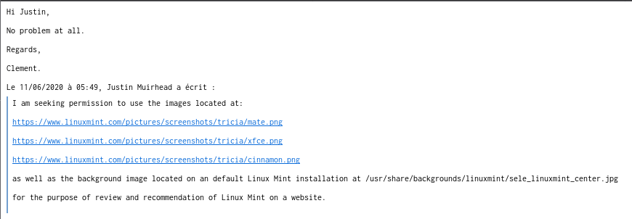They said yes.

# Test Plan & Results

## Test Plan

all of the test results are on GitHub, with screenshots in their respective branches

|  |  |  |
| --- | --- | --- |
| *Test No.* | *What is Being Tested?* | *Expected Result* |
| **1** | Put CSS and HTML through the W3 validators | passes |
| **2** | Ask users in a form to test the website on their browser, test nav links, menu overlay, navbar, etc. | Users reply that it works, follow up with any users who encounter errors |
| **3** | Personally test the website on chromium and Firefox, test nav links, menu overlay, navbar, etc. | Website works |
| **4** | Put pages through Lighthouse validator | Scores are high, and no large issues are brought up |
| **5** |  |  |
| **etc...** |  |  |

## Test Results

### Test template-testing

w3 validator complained about the lack of a <title> in the header, <title> was added. Template otherwise passed the validator check.

### Test frameworkTesting

Put the code through an autoprefixer and through the W3 validators. Code passed W3 validators and changes recommended by the autoprefixer were implemented. Did browser testing on various Apple iPads of various generations. Spotted errors with the loading screen code and fixed them.

### Test final-validation

I put each HTML page through a validators

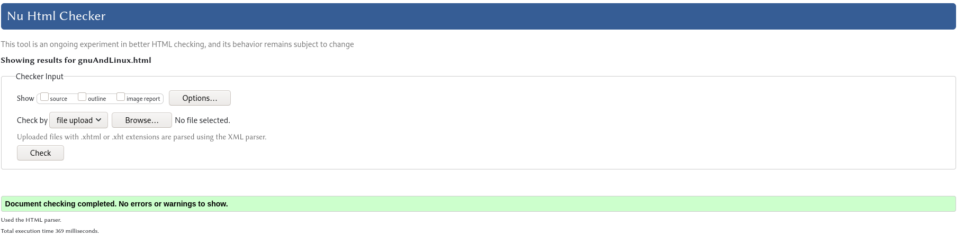

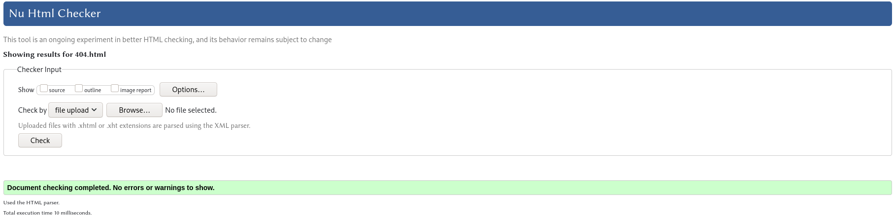

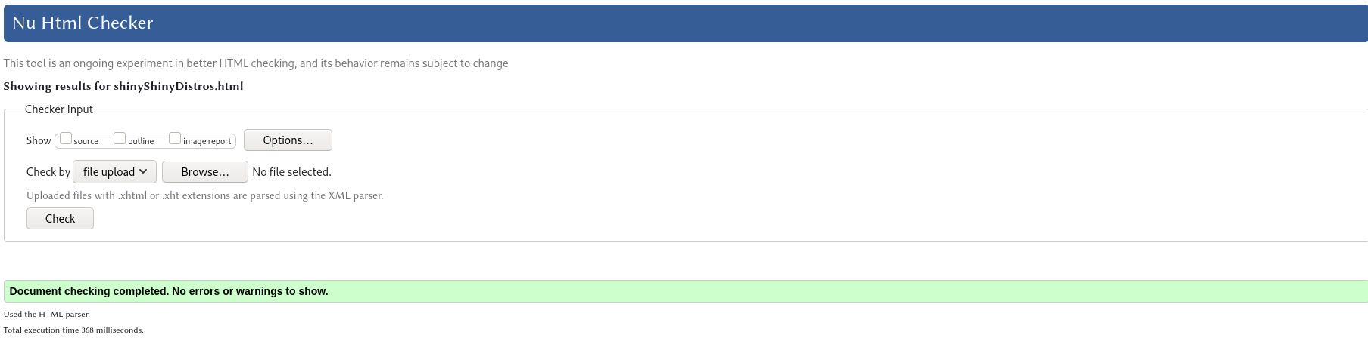But when I validated the index.html page I encountered an error.

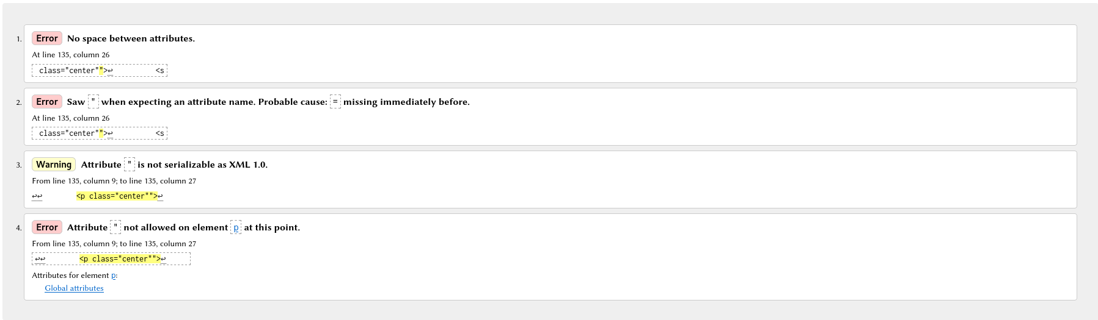I fixed the error by removing the rouge ‘”’ character.

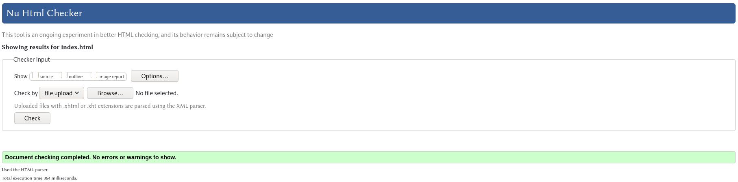And that’s all of my HTML pages validated

I also validated my CSS

This also passed

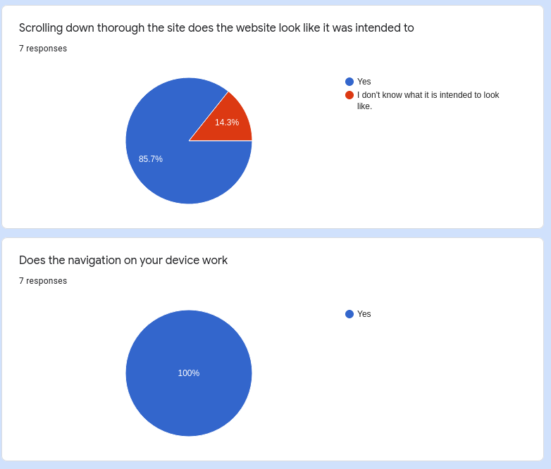From this form, users responded that the website worked for them. I consulted with the user who responded that they didn’t know what the website was meant to look like and they misunderstood the question and the website worked and was functional for them.

I also personally tested the website on Firefox and chromium, the website was functional and proper.

## Changes

One of the design changes I made was to add `border-left` to the `<blockquote>` tag

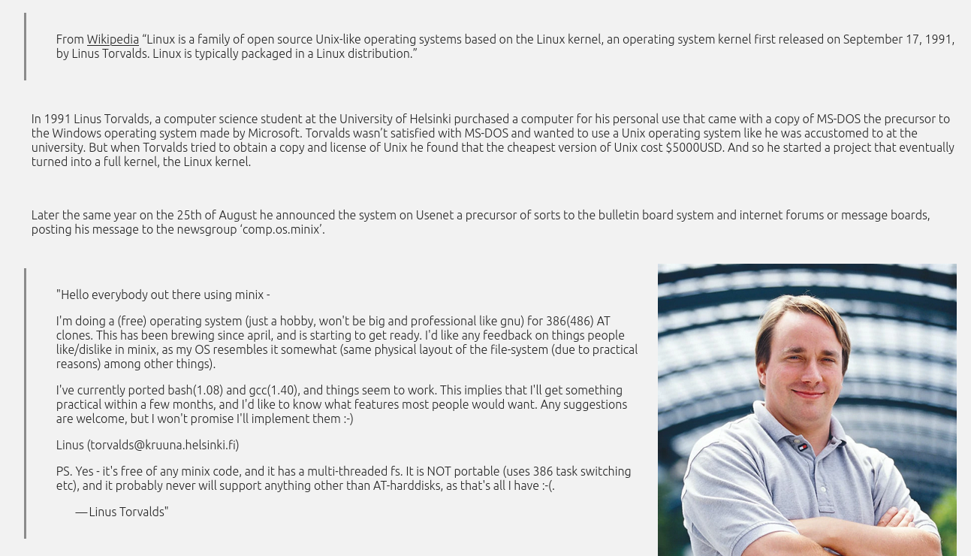This emphasized to the user along with the indent made with `padding-left` that the text is a quote.

Another change I made was to `text-align: center` the `<h1>` and `<h2>` to emphasize them

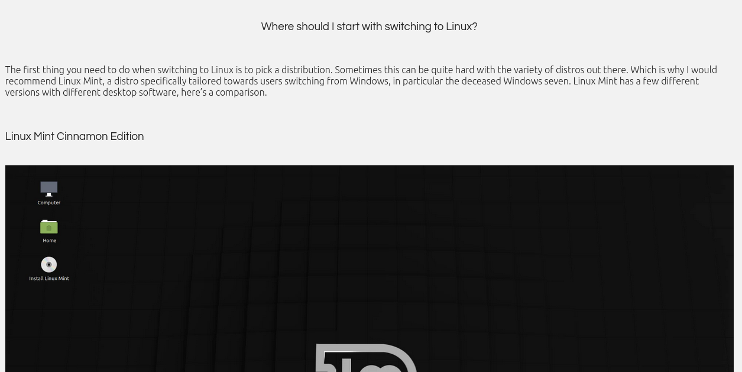One of the first changes I made was to the header, it now looks like this:

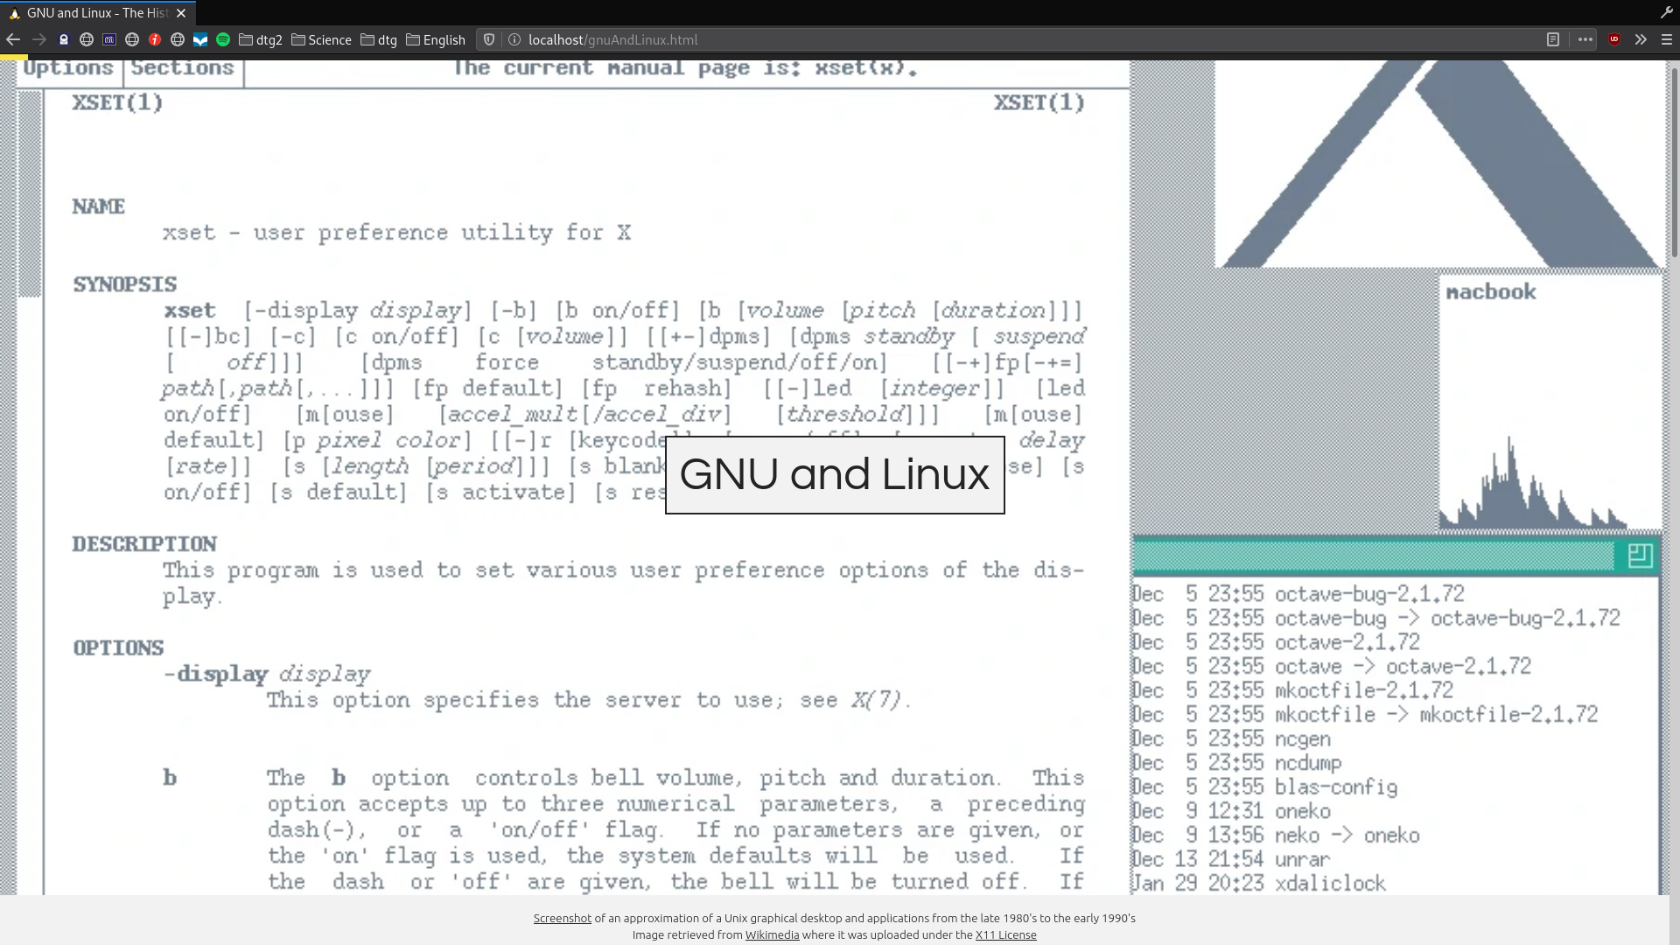I tried to make the `background-color` transparent with no `border` but this decreased readability on certain images, so I decided to add a `border` and a solid `background-color`

Another change I made was to images, on larger displays the centered `<figcaption>` would become unaligned with the `<img>`

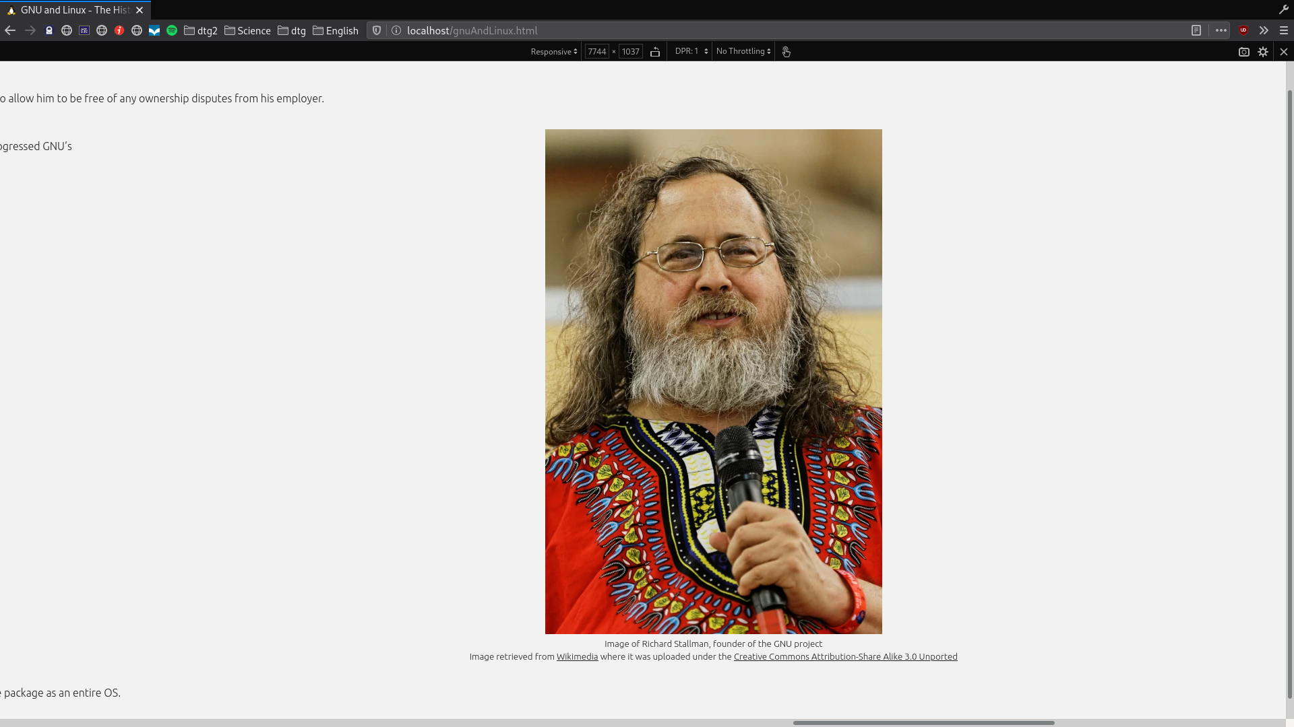I fixed this by adding `left: 50%;` and `transform: translate(-50%, 0%);` to the `<img>`

One of the problems I encountered early on was tux’s head clipping into the navbar when a user first navigated to the site.

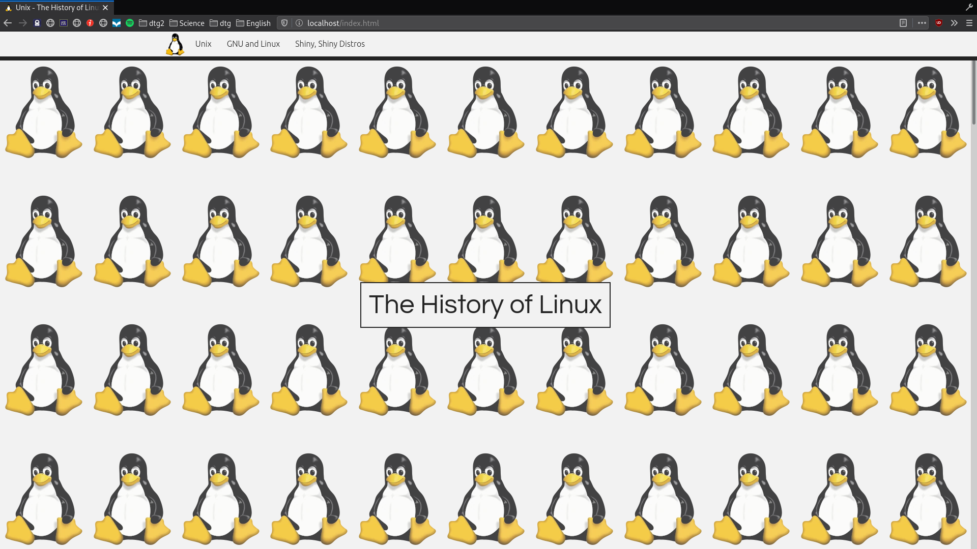If I added a `margin-top: 57px;` to account for the navbar the image would stretch beyond the display. As I was setting the header height using `height:: 100vh;` I couldn’t go `height: 90vh;` to fix it as it would differ between screen sizes. I fixed this with `height: calc(100vh – 57px);` to be screen size unspecific and to let the browser figure it out for itself.

Another early change I made was to my navbar

The `a:hover{background-color}` used to be black with a white `color`, I changed this to go inline with my theming to `background-color: tux-yellow;`.